**Data Structure LAB #2 Homework**

**[H/W 2-1]**

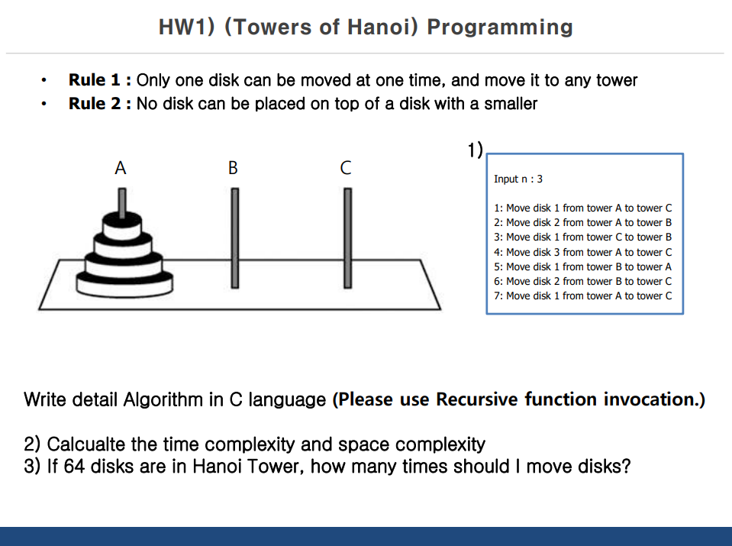

You must print output as same as sample output

**<Input> - Reference “in.txt” file**

Disk count

**<Output> - Reference “sample_out.txt” file**

Move info (written on CLI)

Total move count (written CLI & file) – auto save to “out.txt” file

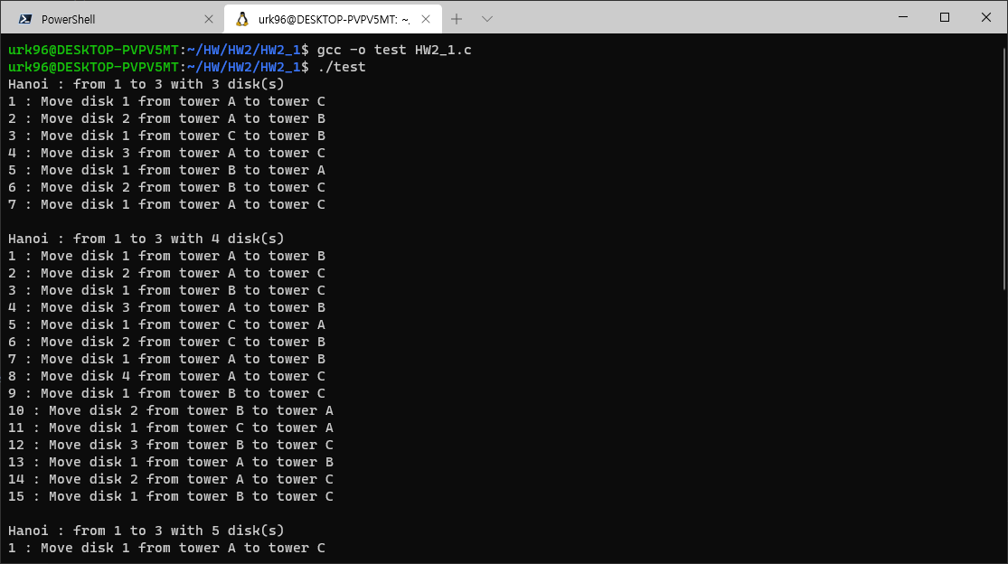

**[H/W 2] – Optional**

Consider below conditions & Implement Binary Search algorithm

**<Condition>**

1. **You can implement binary search algorithm by recursion or loop**
2. **You must consider code reusability (ex. Functionalization)**

**<Input> - Reference “in.txt” file**

Integer Array values & Target values

**<Output> - Reference “sample_out.txt” file**

Find index results – auto save to “out.txt” file

**No CLI output!**